


Module 5 – Assistive Technologies

This Technology and Enterprise unit uses computers and the internet to demonstrate the learning environment utilized by people who are blind or vision impaired. Sections of the Module focus on the T&E outcomes of educational access, the use of the internet with an enlarged screen or voice interface, and the importance of online accessibility.

The following information has been drawn from the Western Australian Curriculum Framework Document and associated Curriculum Guidelines to help teachers place the module in context.

TECHNOLOGY AND ENTERPRISE LEARNING AREA STATEMENTS
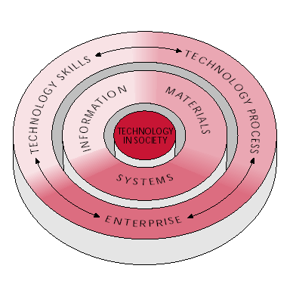
TECHNOLOGY IN SOCIETY

Students understand how cultural beliefs, values, abilities and ethical positions are interconnected in the development and use of technology and enterprise.

…..Students are aware that technological developments inevitably have consequences…..

……They evaluate the appropriateness of technologies on ethical and moral grounds, as well as considering economic advantage and the suitability of products, processes, systems, services and environments for individuals and groups at local, national and international levels….
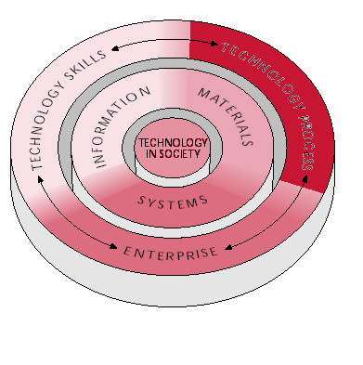
TECHNOLOGY & ENTERPRISE PROCESSES
Students apply a technology process to create or modify products, processes, systems, services or environments to meet human needs and realise opportunities

…..Through their versions of the technology process, students find out more through investigation and research, develop ideas to devise a range of solutions, select and produce a solution and evaluate both the results of their endeavours and the process they adopted….

….When meeting human needs and realizing opportunities, students select how they use the elements of the technology process…

…Students investigate by reflecting on what they already know about the problem or issue they are trying to solve or address…..

….Students devise ways of creating or modifying existing technology based on their understanding of and experience with the materials, information products and processes, and systems they use…..

….They devise solutions by developing a range of ideas that can take into account information they have gathered. They visualize consequences, think laterally, test ideas and represent or communicate to others a range of options……
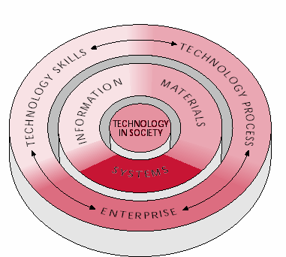
TECHNOLOGY & ENTERPRISE SYSTEMS
Students design, adapt and use systems that are appropriate to achieving solutions to technology challenges.

…….Students understand that systems are combinations of elements that include people and components functioning together to achieve specified goals……

…..Students identify and understand the cause-and-effect relationships within systems and the complexities of assembling or combining tangible or intangible components that interact in an organised way for a particular purpose……

